**Lab Practical #06:**

Study the application layer protocol DNS, DHCP, FTP.

**Practical Assignment #06:**

1. **Implement the application layer protocol DNS, DHCP, and FTP. Also check connectivity between them using ping command or PDU utility.**

# DNS – Protocol Configuration :

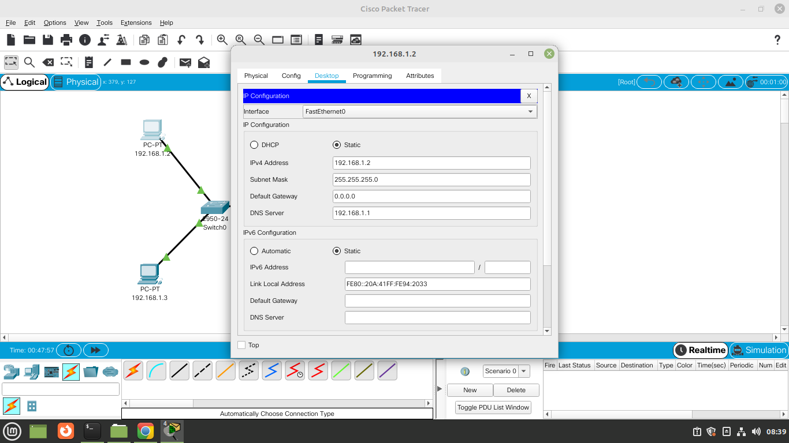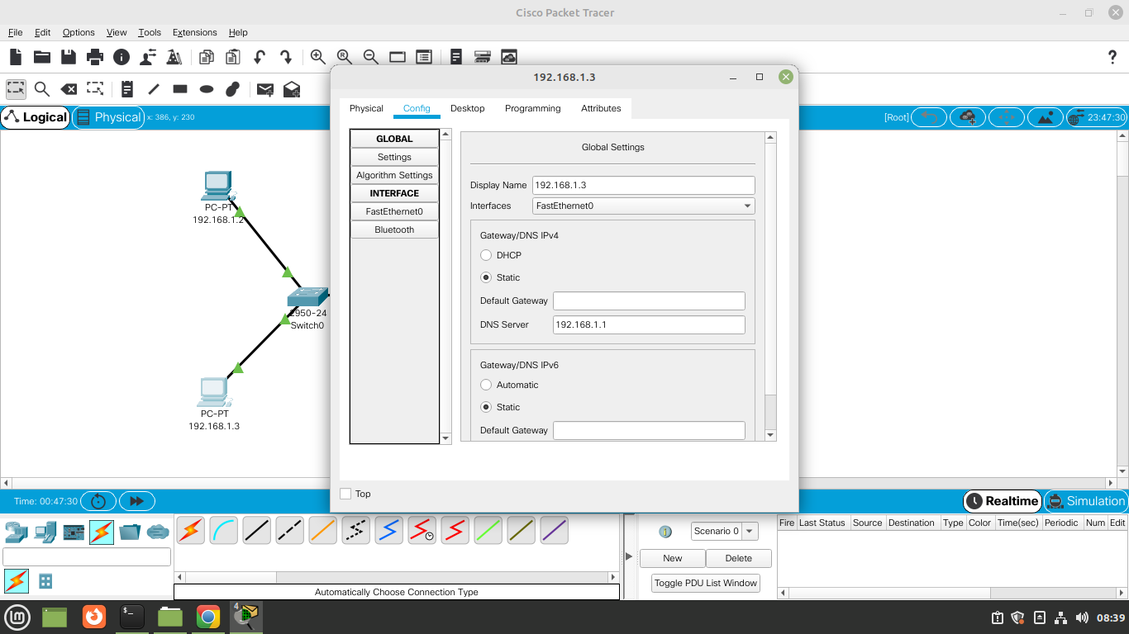

# DHCP Configuration :

# FTP Configuration :

